EVALUATION OF SAFETY AND SECURITY POLICIES

2024 Seminar series organized by
 |  |  | 
 |  | 
This seminar series, continuing the tradition started in 2022, will present some research studies on the evaluation of safety and security policies. The risks addressed by these policies appear to be very far from each other, nevertheless they share some common features and issues than represent a common ground for researchers. For this reason, the seminars will open the discussion over the boundaries of the community of field specialists, with the goal of building a common wisdom as economists. We will explore new concepts and methods to afford the huge challenges that socio-economic analysis and impact evaluation face when addressing safety and security.
The calendar for the 2024 spring edition is:
April 18th | Risk prevention and territories
May 16th | Do fines improve personal data protection?
June 20th | Occupational safety and economic performance: which relationship?

With the scientific patronage of: |  | 

Risk prevention and territories

Thursday 18/04/2024, h. 14:30-16:00
Speakers:
Laurent CARNIS (Université Gustave Eiffel, LMA): Chair’s introduction
Ayman ZOUBIR (CEREMA): Comprehensive understanding of road infrastructure safety policies on French’s secondary road network
David SWAN (Université Gustave Eiffel): Is spending on fire and rescue services inherently inefficient? Evidence from France
Alexandra SCHAFFAR (Université de Toulon): Discussion
Open discussion will follow the presentations.
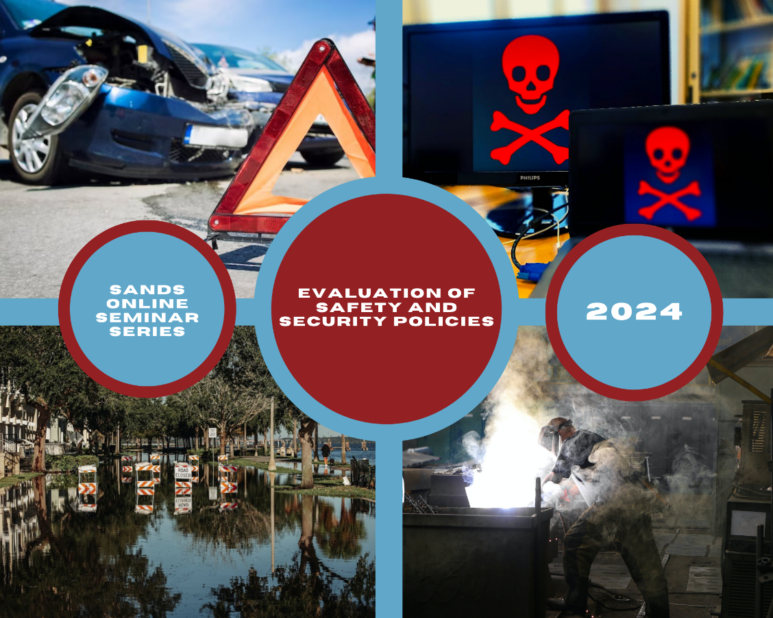

Click here to register to the event; you will receive the zoom link for the webinar
The recordings and presentations of the 2022 and 2023 webinar series are available here: https://drive.google.com/drive/folders/1GjzU76sjzzFOur9zarSIdqjD22-ZScFK?usp=share_link
OUR SPEAKERS

Scientific Committee of the seminar series:
Ayman Zoubir is an urban planner and holds a Ph.D. in urban studies. He applies a multi-disciplinary engineering approach to transportation and urban mobility issues on which he has been working for more than 10 years. He currently works at Cerema as responsible of projects in the fields of mobility and road safety.
Laurent Carnis is a senior Researcher at University Gustave Eiffel. His fields of research deal with public policy analysis, governance and evaluation of road safety policies from an economic point of view. He is also an expert with international organizations (Piarc and Irtad). He is a member of Mosar (research federation) at University Gustave Eiffel.
Elena Ragazzi | Scientific committee & organization | CNR-IRCrES
Laurent Carnis | Scientific committee | Université Gustave Eiffel
Angelo Castaldo | Scientific committee | Sapienza Università di Roma
Ugo Finardi | Scientific committee | CNR-IRCrES
Dominique Mignot | Scientific committee | Université Gustave Eiffel
Marco Modica | Scientific committee | Gran Sasso Science Institute
Albina Orlando | Scientific committee | CNR-IAC
Lisa Sella | Scientific committee | CNR-IRCrES
Nga Le | Scientific secretariat | University of Rome Tor Vergata
In his presentation, Ayman Zoubir will show that understanding crash patterns and addressing safety challenges remains crucial for county councils as road managers of 380,000 km of local roads network. To characterize the road safety policies carried out by county councils and identify measures are a key input for reducing crash frequency and severity. The intervention considers the diversity of territories (geographical, demographic, economic, etc.) and road safety policies to highlight these issues.
For any further information, please write to:
elena.ragazzi@ircres.cnr.it
thunga.le@unito.it

David Swan obtained a PhD in economics from Lyon II University in 2023. His thesis covered the estimation of social benefits created by fire and rescue services, focusing notably on the cause-to-effect relationship between their actions and different socio-economic outcomes. He is currently a post-doctoral research fellow at Gustave Eiffel University, analysing the organisational response to road-traffic accidents in France.
In his presentation, David Swan will discuss the efficiency of fire and rescue services in France. Indeed, there is a general consensus that greater spending on fire and rescue services does not lead to better outcomes (fewer fire deaths). This work examines the veracity of these claims using detailed expenditure data at the county-level across France from 2012 to 2019.
Alexandra Schaffar is Professor of Economics at the University of Toulon. She is the Head of the Institute of Development Studies (LEAD) of Toulon and Head of the Master degree “Maritime Economics and Coastal Development”. Alexandra works on migration, residential mobility, urban growth and quantitative economics.

